Sagittal Balance Course Agenda

Principles for daily practice in DDD

Sagittal balance is a complex topic. In order to understand the concepts, a different type of educational course is needed. This course is modelled on a European program, designed by Professor Jean Charles Le Huec, teaching at Bordeaux university medical school and past Eurospine President and Dr Antonio Faundez, consultant at Geneva University Hospital. Comprehensive approach of the balance concept will be presented.
The course is designed to introduce concepts slowly with adequate time for questioning and discussion before moving on to more advanced concepts. There is a ‘hands on’ approach to measuring parameters on spinal X Rays and the use of software for digital images. The speakers will provide their expertise through didactic presentations and clinical cases precisely selected.
The program will also include practical clinical cases and workshop approach with breakout session to help to identify appropriate treatment. All participants are requested to bring their own cases well documented in a ppt format for open discussion

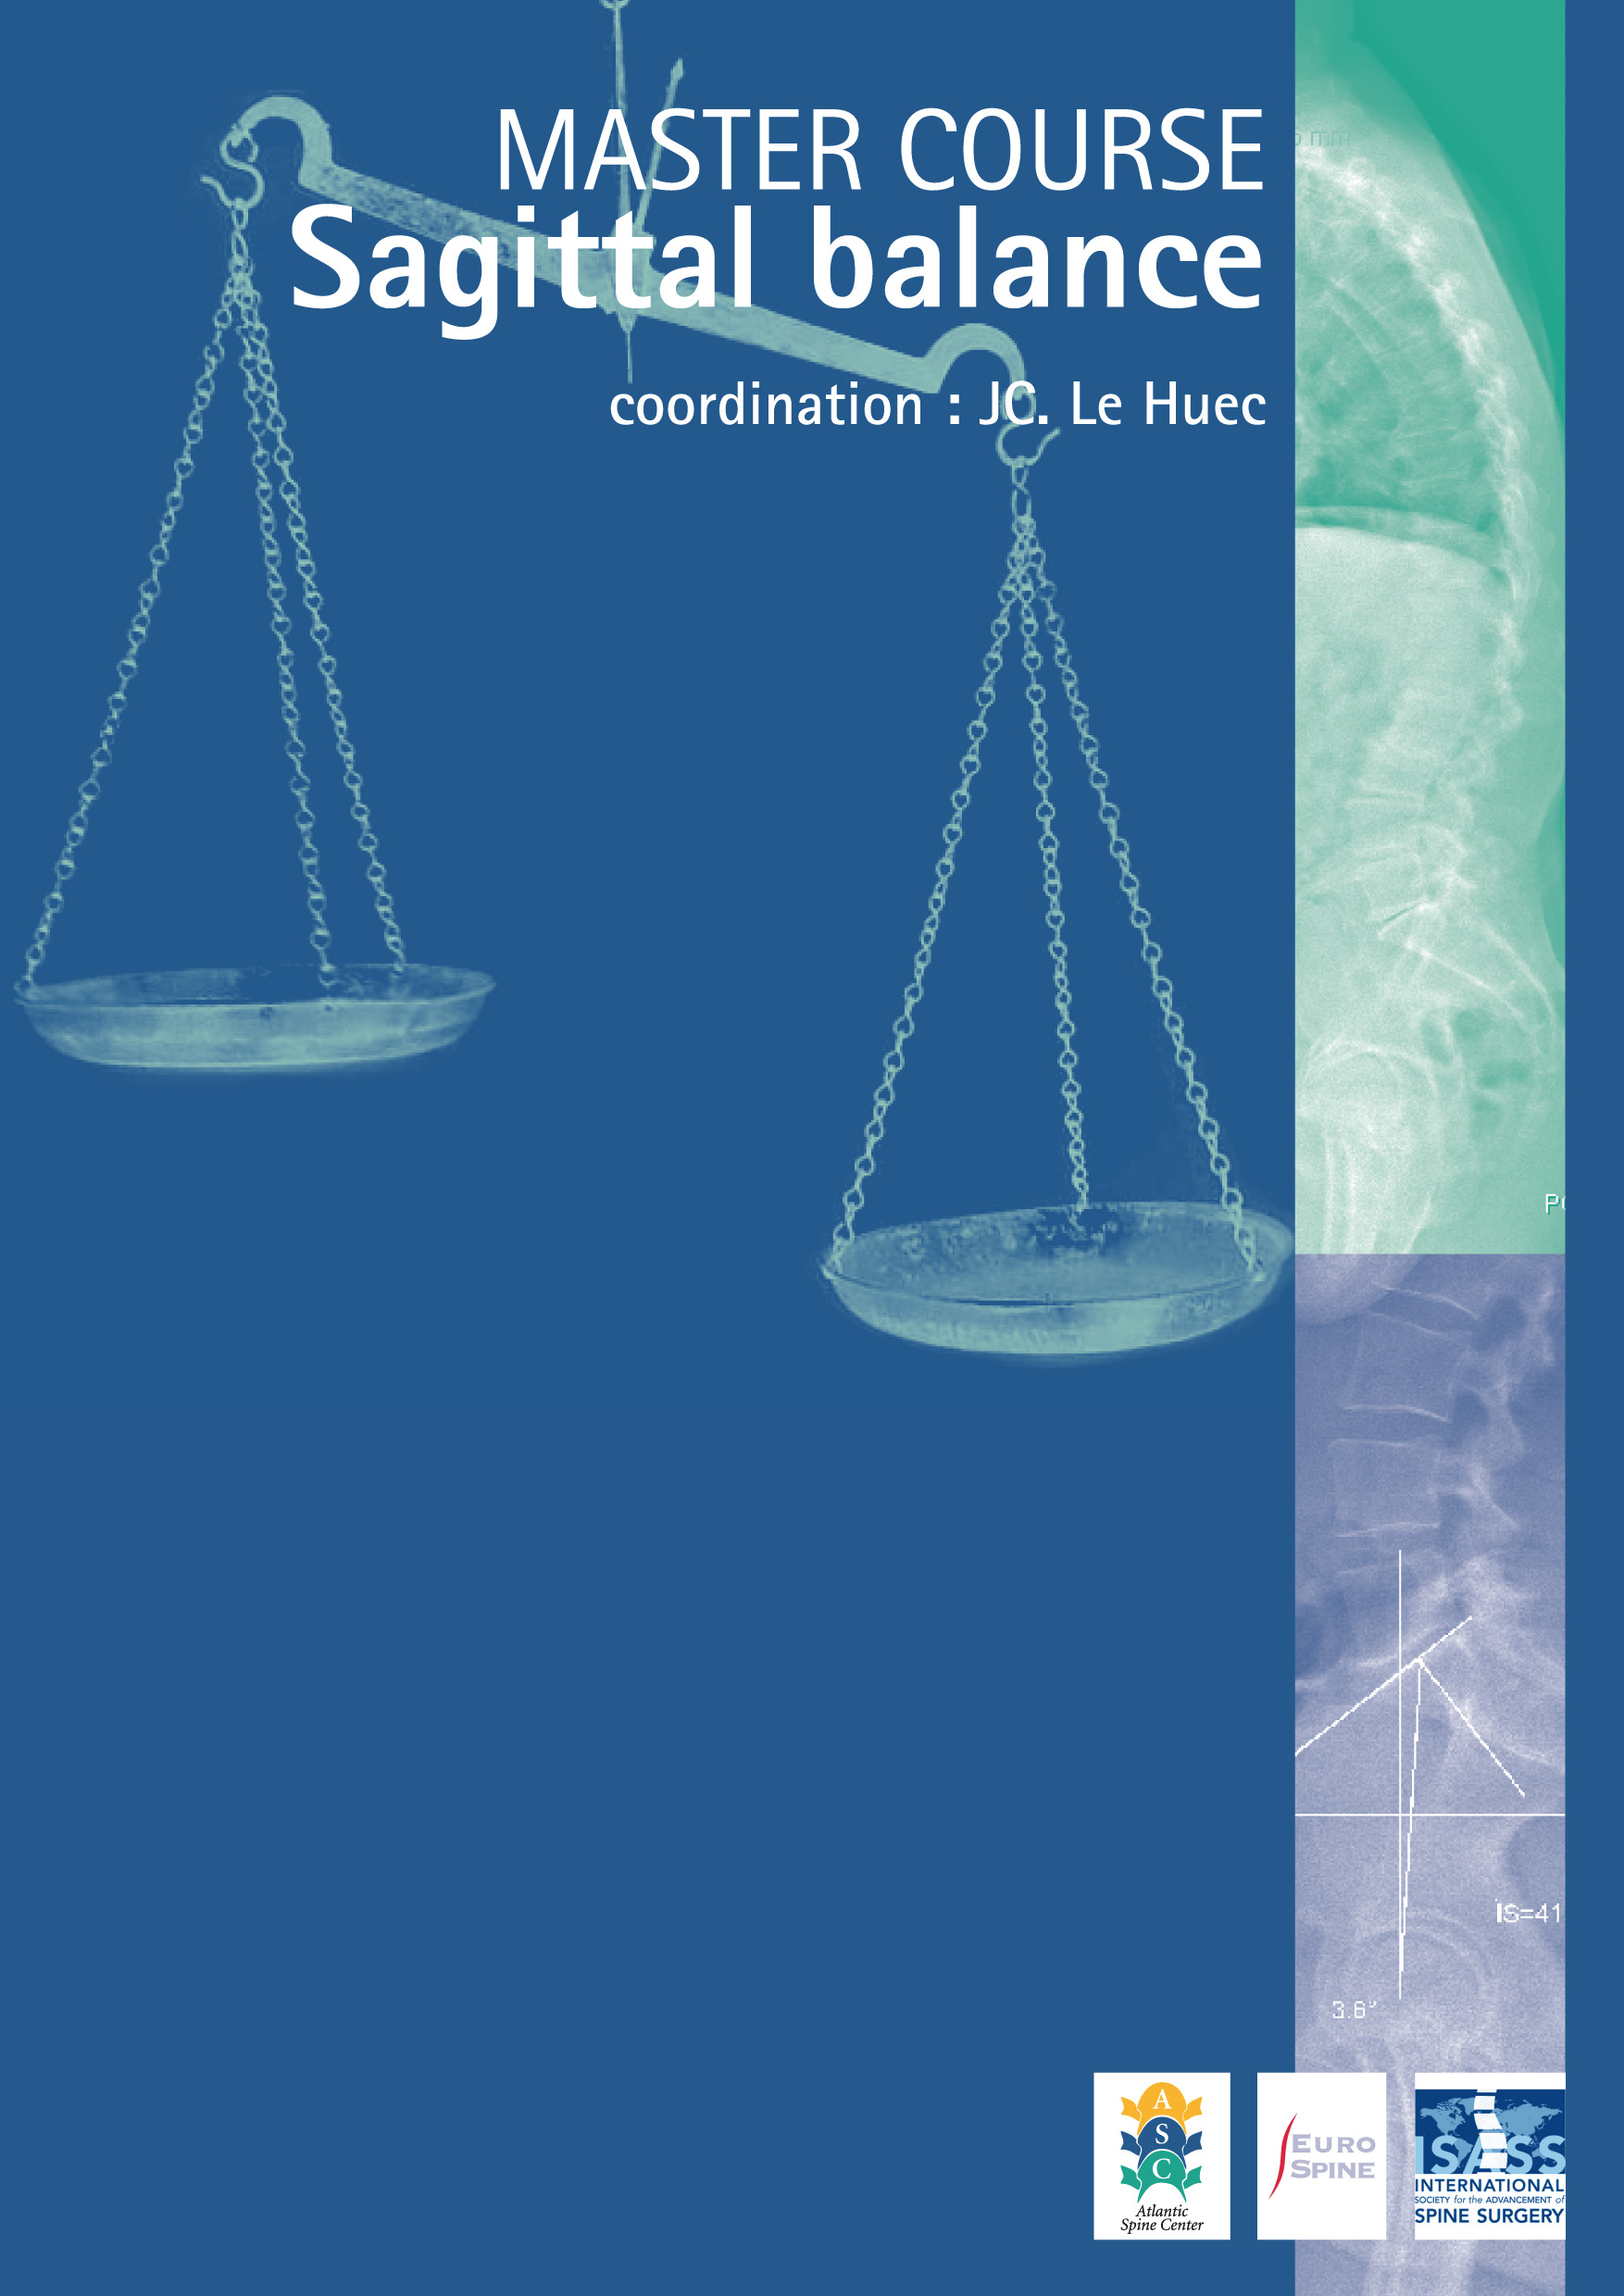

Chairmen : Jean- Charles Le Huec ; Antonio Faundez ;
Speakers : S Genevay, M Aebi, J Franke, D Boscherini

07 45 : welcome : Dr A Faundez and Pr M Aebi, Bern University
07 55 : objectives of the course Pr JC Le Huec

08 00 :
08 15 : biomechanics of spinal balance : LH
- center of gravity
- imbalance and compensatory mechanism
08 25 : spinal imaging of the spine for balance analyzis : D B
- standardize long standing X rays : posture and X ray source
- EOS system :
08 40: discussion

0850 : parameters to analyze the spinal balance
- 08 50 Pelvic parameters : the pelvic vertebra : AF
  - Pelvic parameters, value and significance
  - Clinical cases : analyzis of variations

- 09 10 Spine parameters : JCLH
  - analyzis of the spinal shape and classification of the different shape
  - discussion : on clinical cases
09 30: coffee break and open case discussion

- 10 00 Correlation between spine shape and pelvic shape :
  - Sagittal Spine contour in asymptomatic population
  - discussion on clinical cases

- 10 30 global balance analyzis : C7 plumb line and other parameters:
  - SVA, SSA, Barrey index, FBI index

- 11 00 Cervical spine sagittal aligment
  - new parameters, classification of normal asymptomatic population
  - discussion : clinical cases

- 11 20 Breakout session : workshop : 60mn
  - clinical cases presentation with analysis on :
    - keops database
    - sagittalmeter app (iphone and android)

12 00 : aging process and sagittal balance consequences
- 12 00 analyzis of compensatory mecanisms : JCLH
compensation and imbalance : how to recognize

- 12 15 neurological and muscular consequences : DR GENEVAY
  - radicular and cord consequences
  - muscle atrophy

12 30 LUNCH TIME : on site buffet

13 45 : sagittal balance analyzis in different pathology:

- 13 45 sagittal balance variations and pathology: AF
  - spinal shape and disc herniation, SPL, DDD,
  - could sag balance influence indications : TDR or ALIF

- 14 00 proximal junctionnal kyphosis : biomechanical perspectives : JCLH
  - analyzis of failure
  - biomechanical consequences for thoraco-lumbar fusion methods

- 14 20 case discussion

- 14 45 spondylolisthesis with lysis : LH
  - new classification : 15mn
  - consequence for surgical treatment : 10mn

- 15 00 case discussion
15 15 : coffee break

- 15 45 : degenerative spondylolisthesis without lysis AF
  - analyzis principles and consequence for surgical treatment : (AF )10mn
  - analysis of a prospective multicentric cohort of short lumbar fusion : (J F) : 20mn
  - with clinical cases discussion

- 16 30 kyphosis : iatrogenic and degenerative flat back
  - harmonious kyphosis and angular kyphosis : PSO and SPO strategy : 20mn
  - complications of PSO : how to prevent and manage (15 mn)
  - surgical strategy for old imbalanced patient with claudication : (20mn) M Aebi

17 30 : TAKE HOME MESSAGE : JCLH/AF : 5MN

17 50 coffee break and open case discussion :
product fare : MEDTRONIC, ZIMMER
EOS station visit on request (free)

FREE EVENING or Group restaurant (reservation requested)

DAY 2 : special registration
anatomical WORKSHOP : Chairmen : A Faundez, JC Le Huec, J Fazel
monitor : A Faundez, T Selz, J Franke, M Aebi, D Boscherini, J Duff

08 00 : welcome and preparation for the lab PR Le HUEC

08.30 : anatomy of the nerve root ganglion: Pr Fazel
08 50 : surgical technique of Chevron (SPO) PSO : Dr Faundez
09 05 : cervical osteotomies techniques: J Duff
09 15 : thoracic osteotomies technique: J Franke

09 30: smith petersen , PSO and other various techniques to restore lumbar, thoracic and cervical alignment
5 tables

medtronic :
Table 1 :
Table 2 :
Table 3 :

ZIMMER :
Table 1 :
Table 2 :

open coffee break

12.00 : wrap up and discussion (clinical cases)

13 00: END OF THE COURSE and lunch buffet

